EXPERIMENT – 4

Title:
Task Analysis and User Flow for an Online Shopping App using Lucidchart .

AIM:
To understand and document the steps a user takes to complete main tasks in an online shopping application and to represent them using user flow diagrams.

TOOLS USED:
- Lucidchart

PROCEDURE:

Step 1: Identify Tasks:
The following main tasks in an online shopping app are identified:
- Browsing Products
- Searching for a Product
- Adding Product to Cart
- Checking Out

Step 2: Task Analysis and User Flows:
1. Browsing Products
- User opens the app and lands on the home screen
- User selects a product category
- User views the list of products
- User selects a product to view details
User Flow:
Home Screen → Product Categories → Product List → Product Details

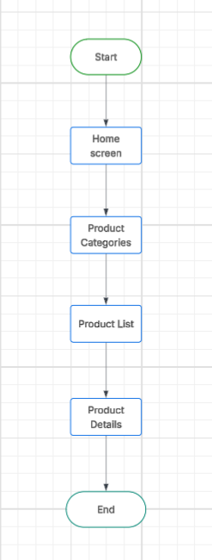
2. Searching for a Product
- User taps on the search bar
- User enters product name or keyword
- System displays search results
- User selects a product to view details
User Flow:
Search → Enter Query → Search Results → Product Details

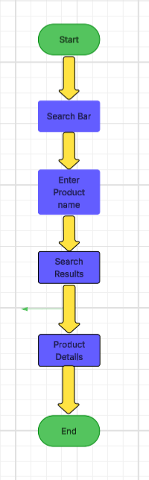
3. Adding Product to Cart
- User browses or searches for a product
- User views product details
- User clicks on “Add to Cart”
User Flow:
View Product → Product Details → Add to Cart
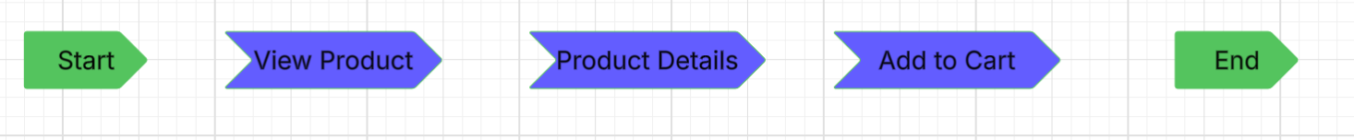
4. Checking Out
- User opens the cart
- User reviews selected products
- User proceeds to checkout
- User enters shipping details
- User enters payment details
- User places the order

User Flow:
Open Cart → Review Cart → Checkout → Shipping Info → Payment Info → Place Order
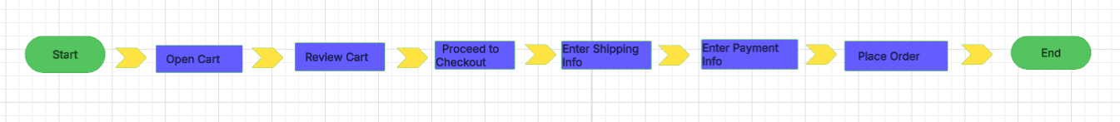
Step 3: Creating Flowcharts
- A new document is created in Lucidchart
- Flowchart shapes like oval (start/end), rectangle (process), and arrows are used
- Each user flow is represented as a flowchart
- All steps are connected properly to show the sequence
Step 4: Final Output
- The flowcharts are reviewed for correctness
- The diagrams are saved and exported as PDF/image

RESULT:
The task analysis and user flows for an online shopping application were successfully created and represented using flowcharts in Lucidchart.

